
Complete
PET

Preliminary
English
Test for Schools

PAPER 1 Reading and Writing
Time: 1 hour 30 minutes

INFORMATION
READING
Questions 1–35 carry one mark.
WRITING
Questions 1–5 carry one mark.
Part 2 (Question 6) carries five marks.
Part 3 (Question 7 or 8) carries 15 marks.

PRACTICE TEST

COMPLETE PET FOR SCHOOLS © CAMBRIDGE UNIVERSITY PRESS 2010 THIS PAGE MAY BE PHOTOCOPIED


READING · PART 1
QUESTIONS 1–5
Look at the text in each question.
What does it say?
Mark the correct letter A, B or C on your answer sheet.
Example:
0 A Karl needs Jack to lend him a bike.
Jack, can you bring the bicycle

you borrowed to my house
today?
Thanks,
Karl
B Jack has to return the bike that Karl lent him.

C Jack is invited to meet Karl at his house and go
cycling.

Answer: 0

A B C

1 A It will be 20 minutes before a city centre bus leaves
BUSES TO THE
LEAVE THIS BUS
STOP EVERY 20
from this stop.
CITY CENTRE
B You can get buses to the centre from here every 20
minutes.
MINUTES C It takes 20 minutes to get to the city centre by bus
from here.

HARRY IS CONTACTING TOM TO

2

Tom,
My mum forgot to get us any
snacks! Can you bring some
when you come to my house
tonight? Jake’s bringing lots of
CDs!

A tell him to provide some music for tonight.

B invite him to Harry’s house tonight.

C ask him to take food with him tonight.

Harry

COMPLETE PET FOR SCHOOLS © CAMBRIDGE UNIVERSITY PRESS 2010 THIS PAGE MAY BE PHOTOCOPIED
1


3 CIARA IS TEXTING BEN TO

Ben,
I’m at the cinema –
where are you? Film
starts in 2 minutes!
Ciara
A warn him he’ll be late for the film.

B ask him to contact her about the film.

C confirm the time the film begins.

4 WHAT IS MUM REMINDING BILLY TO DO?

Billy, the
Your sandwiches are in
fridge – put them in your
lunchbox .
Don’t forget!
Mum
A make sandwiches for his lunch

B take his lunchbox out of the fridge

C add his sandwiches to his lunchbox

5 A Pupils are late paying for the school trip on Friday.
PUPILS SHOULD

BRING MONEY FOR
THE SCHOOL TRIP
BY FRIDAY AT THE
LATEST
B Pupils have until Friday to pay for the school trip.

C Pupils should bring money to spend during Friday’s
school trip.

COMPLETE PET FOR SCHOOLS © CAMBRIDGE UNIVERSITY PRESS 2010 THIS PAGE MAY BE PHOTOCOPIED
2






READING · PART 2
QUESTIONS 6–10
The teenagers below all want to visit a museum exhibition in their city.
On the opposite page there are descriptions of eight different exhibitions to visit.
Decide which exhibition would be the most suitable for the following teenagers.
For questions 6–10, mark the correct letter (A–H) on your answer sheet.

6 Sarah likes inventing useful things and finding out how new inventions are
designed and produced. She’s good at using computers, and wants to see how
they can be used in design.

7 Jake is keen on large vehicles and machines, and would like to go somewhere
he can have experience of one actually working. He’d also like to take some
good photos.

8 Marta is doing a project on the environment and the effects of waste products
we throw away. She wants to learn more about the problem and what
individuals can do about it.

9 Tom likes animals and wants to understand more about them. He wants to go
somewhere he can take part in activities and buy a souvenir to make at home.

10 Karina is keen on art and photography. She likes exploring areas of the city to
see what things she can find for her art, and then put them into her work.

COMPLETE PET FOR SCHOOLS © CAMBRIDGE UNIVERSITY PRESS 2010 THIS PAGE MAY BE PHOTOCOPIED
3

A Smithson Museum
Come along and see this exhibition of
everything to do with animals – from
unusual animal prints to the latest computer
designs of cartoon animals for films. Try
designing a new and fantastic film creature
on the computer – you might even see it
appear in a film!

C Railton Museum
A visit to this museum all about the
city’s river includes a 40-minute ride
in a huge boat along the water – at
great speed! You can also have your
photo taken during the trip – but don’t
even think about trying to take your
own. You’ll be too wet!
E The Allen Centre
Got a great idea to share? Come and
take part in this exhibition about how
machines are made, from the idea to
the finished product. See how IT can
help with plans for models. And come
and work on your idea here – the best
ones will go into the display!
G Bedford Lock
Come down to the river bank and take photos of
this temporary exhibition – 200 kilos of plastic
rubbish, collected from our river! Get ideas
about how we can each help to tidy up our
world – but also don’t miss the display of useful
plastic items such as computer and machine
parts.

B The Willis Centre
Come and join the museum’s
guided walks along the river bank.
You’ll collect objects that have come
from the river, such as interesting
stones and old pieces of wood and
machines. And then try making
pictures with what you’ve picked
up!

D Park Pavilion
Art galleries not usually for you? Then visit this
Art in the Park exhibition – young people’s art and
photography about problems in our environment.
There’s everything, from art produced on computers
to teenagers’ wildlife photos. Come and put some of
your work in the display!

F Hampton House
This technology museum is full of models of
engines – and a big wheel! Climb on, sit down
and be taken up high enough to see over the
rooftops! And don’t forget your camera – you’ll
get some amazing pictures! Model engines are
on sale in the gift shop.

H Camford Museum
The exhibition here is based around
large models showing how living
creatures use their amazing skills in the
wild. Dress up like a jungle creature to
discover how they deal with a changing
environment. Or help build a model of a
giraffe – and even get one from the shop

to take away!

COMPLETE PET FOR SCHOOLS © CAMBRIDGE UNIVERSITY PRESS 2010 THIS PAGE MAY BE PHOTOCOPIED
4

READING · PART 3
QUESTIONS 11–20
Look at the sentences below about a girl called Anna and her new school building.
Read the text on the next page to decide if each sentence is correct or incorrect.
If it is correct, mark A on your answer sheet.
If it is not correct, mark B on your answer sheet.

11 Anna’s school is the first one in her country to be made completely of wood.

12 Anna had mixed feelings about seeing the space cleared ready for building the school.

13 Builders managed to carry on with work on the school despite the weather.

14 There is one room that is kept just for local people to use for meetings.

15 The children find the new changing rooms convenient when they do sports on their field.

16 The inside of Anna’s school depends on the people and machines in it to be warm.

17 The new school building has great benefits for people who like to sing.

18 The builders wanted to do something traditional for the school when they’d finished the roof.

19 Pictures of the wind turbine behind the school can now be seen online.

20 The pupils are busy preparing to do a performance for their parents in their new school building.

COMPLETE PET FOR SCHOOLS © CAMBRIDGE UNIVERSITY PRESS 2010 THIS PAGE MAY BE PHOTOCOPIED
5


Anna’s new school
It’s been a very exciting week, as we’ve just moved into our
new school building! It’s an amazing place, as the builders
have used wood for the whole thing, just like in our old
school, but it’s also one of the first in my country designed to
be really environmentally friendly.

The school took months to build, so we saw it all happening.
It was really exciting seeing the builders clear the space
where it would be, although it also meant that some lovely
open land disappeared. And the noise of the building
machines was really loud, although the builders often had to
stop work because it rained so hard. We all began to think the
building would never be finished.

We have five classrooms now, which are enormous – much
bigger than in our previous school next door, which was very
old. We share one room with people in the town when they
want to have meetings and so on. There’s a nursery too, a
lovely dining room, and really big changing rooms which
we’re looking forward to using as soon as our new sports field
is ready.

When you come into the school, one of the first things you
notice is that there aren’t any heaters in the building! Instead,
the heat for the school comes from all of us inside it – the
children, the teachers and the computers we use. The building
is so well designed that it holds all the heat inside – and all
the sound too, so if we sing inside our classrooms, we can almost believe we’re inside a concert hall!

Another thing you’ll notice is that the school roof has a tree on top of it! It was put there by the builders once
they’d finished the roof, because they said it was the custom in Austria, the country where the roof was made.
The electricity for lights and computers comes from a wind turbine on a hill behind the school. We went with
our teacher to look at it yesterday, and it goes round really fast. It’s so big, it can be seen for miles! We took
some pictures which we’re planning to put on the website.

Even though we’re already using the school building, there are still some parts to be added to it – for example,
at the moment we’re putting on a play for parents to come and see, but we still have to walk back to our old
school hall to do it. The replacement will be ready by next year, though. We’re so pleased with our new school,
and our teachers say we’ll all learn much faster now we’re in it!

COMPLETE PET FOR SCHOOLS © CAMBRIDGE UNIVERSITY PRESS 2010 THIS PAGE MAY BE PHOTOCOPIED
6

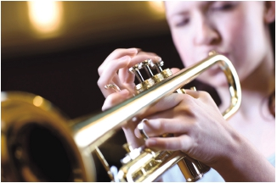
READING · PART 4
QUESTIONS 21–25
Read the text and questions below.
For each question, mark the correct letter A, B, C or D on your answer sheet.

JAZZ
By Katie Atkins, aged 14

I play the trumpet in my school jazz band. Last month we held a jazz competition with bands from
local high schools – and our band won!
Each band had their own costumes, ranging from black school uniforms like my band wore, to
brightly-coloured T-shirts. We didn’t look much like adult professional bands, but all of us were
used to performing in competitions, so the quality of playing was amazing, especially considering
everyone was so young. Players from each band even created new tunes right there on stage. It was
exciting to watch – but even better when my band played on stage!
We have a great jazz band at my school, but not everyone who wants to play in it gets accepted –
only about half, in fact. But anyone who’s keen to play goes to jazz practice before school, and we
often spend time together after school, listening to jazz and learning its language. There are also trips
to jazz summer camps across the country – I’ve been to a couple and learnt a lot.
Adults are often surprised that young people are getting interested in jazz. My music teacher thinks
it’s because pop music isn’t challenging enough for people like me who are serious about music. But
I find it exciting because it’s both new and old at the same time – you can create your own music,
but you also feel you’re part of its history, as you’re playing on stage in the same way as great jazz
performers before you.
My school’s really lucky because we have great teachers, and parents who’ve supported us all the
way. Without them, we’d never get anywhere with our music!

COMPLETE PET FOR SCHOOLS © CAMBRIDGE UNIVERSITY PRESS 2010 THIS PAGE MAY BE PHOTOCOPIED
7

21 What is Katie trying to do in the text?
A encourage young people to try to listen to more jazz
B explain how jazz is becoming popular with young people
C advertise young people’s jazz events in her area
D give advice on how to create great jazz music

22 Katie says the bands in her school’s jazz competition
A played music they’d written themselves before they came.
B had little experience of playing in public.
C played at a high level despite their age.
D were dressed to look like professional jazz bands.

23 Most people at Katie’s school who are interested in jazz
A attend early jazz sessions at school.
B join the school jazz band.
C learn about jazz in after-school classes.
D go to jazz summer camps at the school.

24 Why does Katie enjoy playing jazz so much?
A She finds it easier to learn than other forms of music.
B She thinks it is more serious than pop music.
C She likes the chance to perform with others on stage.
D She feels in touch with jazz players of the past.

25 Which of the following would Katie write to a friend?

A The competition was great, but
I think I preferred being in the
audience to playing – I was nervous!

C One band wore really colourful
clothes, but we chose dark
costumes. Maybe that’s one reason
why they won instead of us.
B My mum and dad always do all they
can to help with my trumpet playing
– I couldn’t do this successfully
without their help.

D One music teacher left a while ago
and no one’s replaced him yet. We
just haven’t got anyone good to help
us now.

COMPLETE PET FOR SCHOOLS © CAMBRIDGE UNIVERSITY PRESS 2010 THIS PAGE MAY BE PHOTOCOPIED
8

READING · PART 5
QUESTIONS 26–35
Read the text below and choose the correct word for each space.
For each question, mark the correct letter A, B, C or D on your answer sheet.
Example:

0 A one B some C any D many

Answer: 0

A B C D

Sharks
Sharks are (0) of the most frightening creatures in our oceans. They

are well prepared for feeding under water because they can (26)

very well, and they can also (27) movement through special lines

on the sides of their bodies. These make sharks very (28) for

smaller sea creatures that become their food.

Although sharks are similar (29) other fish in a

number of ways, their bodies are different. For example, unlike other fish, most sharks

(30) to swim all the time in order to breathe and stay alive,
(31) they hardly sleep at all. Also, if sharks are turned over

on their backs, they can stop moving (32) . This is a very

useful technique for researchers (33) are often required to

(34) sharks. It allows them to (35)

out more about these fascinating creatures.

COMPLETE PET FOR SCHOOLS © CAMBRIDGE UNIVERSITY PRESS 2010 THIS PAGE MAY BE PHOTOCOPIED
9

26 A watch B look C notice D see

27 A touch B feel C know D catch

28 A dangerous B difficult C serious D important

29 A with B from C to D of

30 A ought B need C must D should

31 A so B as C but D or

32 A perfectly B finally C fully D completely

33 A which B who C what D whose

34 A sort B care C deal D handle

35 A discover B search C find D study

COMPLETE PET FOR SCHOOLS © CAMBRIDGE UNIVERSITY PRESS 2010 THIS PAGE MAY BE PHOTOCOPIED
10

WRITING · PART 1
QUESTIONS 1–5
Here are some sentences about a school art exhibition.
For each question, complete the second sentence so that it means the same as the first.
USE NO MORE THAN THREE WORDS.
Write only the missing words on your answer sheet.
You may use this page for any rough work.
Example:
0 We had an exhibition of our art work in the school hall last night.
THERE AN EXHIBITION OF OUR ART WORK IN THE SCHOOL HALL LAST
NIGHT.
Answer: 0 was

1 Unfortunately we had too many pictures to put on the walls.
UNFORTUNATELY WE DIDN’T SPACE FOR ALL OUR PICTURES.

2 The photos in the exhibition were taken by the youngest pupils.
THE YOUNGEST PUPILS THE PHOTOS IN THE EXHIBITION.

3 I don’t think I put my best pictures in the exhibition.
I’VE PRODUCED PICTURES THAN THE ONES I PUT IN THE EXHIBITION.

4 There were such a lot of people that I couldn’t find my friends.
THERE WERE PEOPLE THAT I COULDN’T fiND MY FRIENDS.

5 Our parents all said that we should have another exhibition soon.
OUR PARENTS ALL SAID ‘WHY HAVE ANOTHER EXHIBITION SOON?’

COMPLETE PET FOR SCHOOLS © CAMBRIDGE UNIVERSITY PRESS 2010 THIS PAGE MAY BE PHOTOCOPIED
11


WRITING · PART 2
QUESTION 6
You have just been to the town centre to spend some birthday money on a book. Write an email to your
English friend, Sam. In your email you should:
· SAY WHAT KIND OF BOOK YOU BOUGHT
· SAY WHY YOU CHOSE THE BOOK
· SUGGEST WHEN YOU CAN SHOW YOUR FRIEND WHAT YOU BOUGHT.
Write 35–45 WORDS on your answer sheet.

WRITING · PART 3

Write an answer to ONE of the questions (7 or 8) in this part.
Write your answer in about 100 WORDS on your answer sheet.

QUESTION 7
· THIS IS PART OF A LETTER YOU RECEIVE FROM YOUR ENGLISH FRIEND PAT.

My family and I are coming to visit your area soon. Can you tell me some good
places for us to go? And what will the weather be like while we are there?

· NOW WRITE A LETTER, ANSWERING PAT’S QUESTIONS.
· WRITE YOUR LETTER on your answer sheet.

QUESTION 8
· YOUR ENGLISH TEACHER ASKS YOU TO WRITE A STORY.
· THIS IS THE TITLE FOR YOUR STORY:
‘The day we went to the zoo!’
· WRITE YOUR STORY on your answer sheet.

COMPLETE PET FOR SCHOOLS © CAMBRIDGE UNIVERSITY PRESS 2010 THIS PAGE MAY BE PHOTOCOPIED
12


Complete
PET

Preliminary
English
Test for Schools

PAPER 2 Listening
approx. 35 minutes (including six minutes’ transfer time)

INFORMATION
There are four parts to the test.
Each question carries one mark.
For each part of the test there will be time for you to look through the questions and time for you to check
your answers.

PRACTICE TEST

COMPLETE PET FOR SCHOOLS © CAMBRIDGE UNIVERSITY PRESS 2010 THIS PAGE MAY BE PHOTOCOPIED

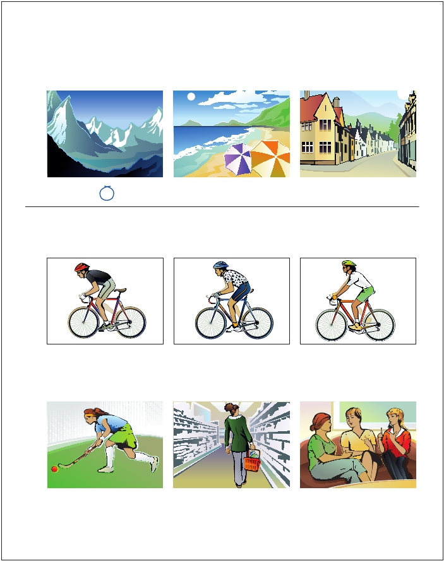
LISTENING · PART 1
QUESTIONS 1–7
There are seven questions in this part.
For each question, choose the correct answer (A, B or C).
Example: Where did the girl and her family go on holiday?

A B C

1 Which cyclist won the race?

A B C

2 Why couldn’t the girl go to photography club yesterday?

A B C

COMPLETE PET FOR SCHOOLS © CAMBRIDGE UNIVERSITY PRESS 2010 THIS PAGE MAY BE PHOTOCOPIED
1

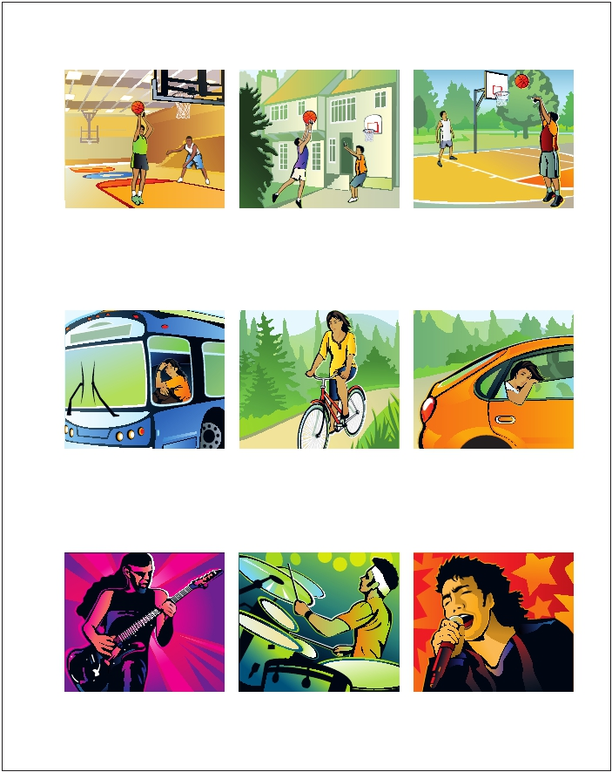
3 Where will the boy and his friend practise basketball?

A B C

4 How did the girl get to school?

A B C

5 Which music poster does the boy prefer?

A B C

COMPLETE PET FOR SCHOOLS © CAMBRIDGE UNIVERSITY PRESS 2010 THIS PAGE MAY BE PHOTOCOPIED
2


6 Where will they go after the cinema?

A B C

7 What will Sam take on the school museum trip tomorrow?

A B C

COMPLETE PET FOR SCHOOLS © CAMBRIDGE UNIVERSITY PRESS 2010 THIS PAGE MAY BE PHOTOCOPIED
3

LISTENING · PART 2
QUESTIONS 8–13
You will hear an interview with a student called Sarah Mercer, who is planning to become a weather
forecaster. For each question, choose the correct answer A, B or C.

8 Why did Sarah first become interested in the weather?
A She studied weather in school science lessons.
B She had experience of bad weather where she lived.
C She saw programmes about weather on TV.

9 Who encouraged Sarah’s interest in the weather at home?
A her mother
B her father
C her grandfather

10 Pupils at Sarah’s school club
A produced a book about the weather.
B provided information to the school for projects.
C set up equipment for studying the weather.

11 What mistake did Sarah’s family make during a sailing trip?
A They didn’t recognise signs of bad weather coming.
B They hadn’t made preparations for bad weather.
C They failed to check weather forecasts regularly.

12 Sarah thinks in future she’d like to
A work in the area of sport.
B be on TV weather programmes.
C travel abroad for her job.

13 What kind of weather does Sarah like best?
A when the sun is shining
B when it’s raining hard
C when there’s fog

COMPLETE PET FOR SCHOOLS © CAMBRIDGE UNIVERSITY PRESS 2010 THIS PAGE MAY BE PHOTOCOPIED
4


LISTENING · PART 3
QUESTIONS 14–19
You will hear an art teacher talking to a class about a design competition run by an online magazine.
For each question, fill in the missing information in the numbered space.

Design Competition

DETAILS:

Name of magazine: (14) Designs

Design a (15) for the magazine.

The design must include a (16) .

Entries can be sent in up to (17) May.

If possible, pupils should also send their (18) with
the entry.

The winning school will receive a (19) .

COMPLETE PET FOR SCHOOLS © CAMBRIDGE UNIVERSITY PRESS 2010 THIS PAGE MAY BE PHOTOCOPIED
5

LISTENING · PART 4
QUESTIONS 20–25
Look at the six sentences for this part.
You will hear a boy, Mark, and a girl, Anna, talking about winter sports.
Decide if each sentence is correct or incorrect.
If it is correct, choose the letter A for YES. If it is not correct, choose the letter B for NO.

YES NO

20 Mark was disappointed at the amount of snow at his holiday centre. A B

21 Anna is surprised at how quickly Mark learnt to snowboard. A B

22 Mark thinks it’s important to be fit in order to snowboard well. A B

23 Anna is shocked that some people don’t protect themselves better when A B
snowboarding.

24 Mark is keen to learn more advanced snowboarding in future. A B

25 Anna and Mark both prefer doing snowboarding to other winter sports. A B

COMPLETE PET FOR SCHOOLS © CAMBRIDGE UNIVERSITY PRESS 2010 THIS PAGE MAY BE PHOTOCOPIED
6

PAPER 3: SPEAKING

PART 1 2–3 minutes

Phase 1
INTERLOCUTOR

[TO BOTH STUDENTS] Good morning/afternoon/evening.
Can I have your mark sheets, please?
(Students hand over the mark sheets to the Assessor.)
I’m and this is .
He / She is just going to listen to us.
[TO STUDENT A] Now, what’s your name?

Thank you.
[TO STUDENT B] And what’s your name?

Thank you.
BACK-UP PROMPTS

B Candidate B, what’s your surname?
How do you spell it?
Thank you.
A And, Candidate A, what’s your surname?
How do you spell it?
How do you write your family/second
name?

How do you write your family/second
name?

Thank you.
Do you like it? Do you have English lessons?

(Interlocutor asks the following questions.
Use candidates’ names throughout. Ask
Candidate A first.)
Where do you live/come from? Do you live in …?
Do you study English at school?

Thank you.
(Repeat for Candidate B.)

COMPLETE PET FOR SCHOOLS © CAMBRIDGE UNIVERSITY PRESS 2010 THIS PAGE MAY BE PHOTOCOPIED
1

Phase 2
What? What do you like doing when you’re not
INTERLOCUTOR

(Select one or more questions from the list to ask each candidate. Use candidates’ names throughout.
Ask Candidate B first.)

BACK-UP PROMPTS
Do you enjoy studying English? Do you like studying English?
How will you use English in the future? What did you do during your last school
holiday?
Did you do anything in your last school holiday?
at school?
Tell us about your family.

Thank you.

(Introduction to Part 2)
In the next part, you are going to talk to each other.

COMPLETE PET FOR SCHOOLS © CAMBRIDGE UNIVERSITY PRESS 2010 THIS PAGE MAY BE PHOTOCOPIED
2

PAPER 3: SPEAKING (Walking Trip)

PART 2 2–3 minutes

INTERLOCUTOR
[to both students]:

I’m going to describe a situation to you.
You’re both going on a three-day school WALKING trip in the COUNTRYSIDE. Talk together
about the things you will need, and decide which are the most important things to TAKE
with you.
Here is a picture with some ideas to help you.

[give students Part 2 booklet]

I’ll say that again.
You’re both going on a three-day school WALKING trip in the COUNTRYSIDE. Talk together
about the things you will need, and decide which are the most important things to TAKE
with you.

All right? Talk together.

Candidates complete the task without intervention.
Prompt only if necessary, by repeating parts of the question.

Thank you. (Can I have the booklet please?)

Retrieve Part 2 material.

COMPLETE PET FOR SCHOOLS © CAMBRIDGE UNIVERSITY PRESS 2010 THIS PAGE MAY BE PHOTOCOPIED
3

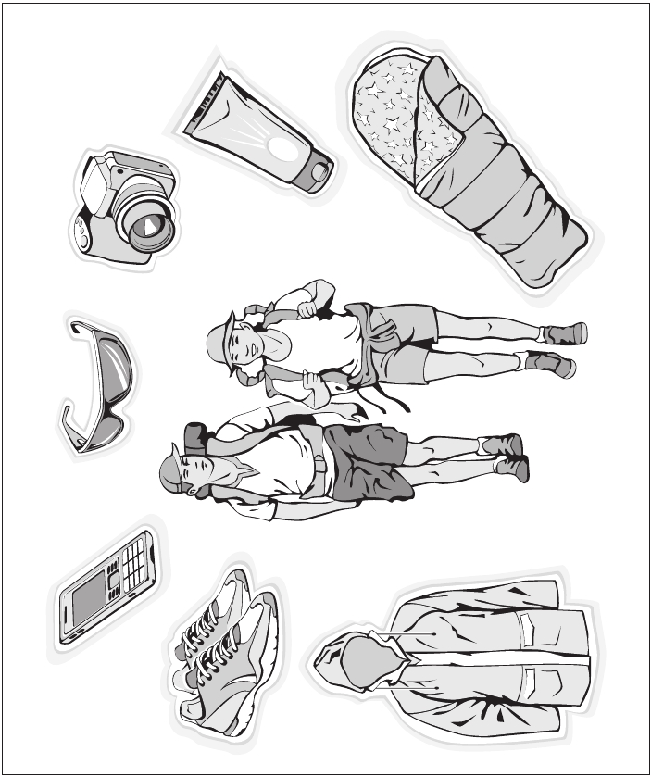
PAPER 3: SPEAKING

PART 2

COMPLETE PET FOR SCHOOLS © CAMBRIDGE UNIVERSITY PRESS 2010 THIS PAGE MAY BE PHOTOCOPIED
4

PAPER 3: SPEAKING (Special clothes)

PART 3 3 minutes

INTERLOCUTOR
[to both students]:

Now, I’d like each of you to talk on your own about something. I’m going to give each of you a
photograph of PEOPLE WEARING SPECIAL CLOTHES.
[to student A]
Candidate A, here is your photograph (Task 1A). Please show it to Candidate B, but I’d like you to
talk about it. Candidate B, you just listen. I’ll give you your photograph in a moment.
Candidate A, please tell us what you can see in your photograph.

Thank you. [take back booklet]

Now, Candidate B, here is your photograph (Task 1B). It also shows SOMEONE WEARING SPECIAL
CLOTHES. Please show it to Candidate A and tell us what you can see in the photograph.

Thank you. [take back booklet]

PART 4 3 minutes
INTERLOCUTOR
[to both students]:

Your photographs showed people wearing special clothes. Now, I’d like you to talk together about
the different kinds of clothes you might wear for different occasions.

The interlocutor will allow enough time to complete the task without intervention. They may ask
further questions if candidates do not fill the time available.

Thank you. That’s the end of the test.

BACK-UP PROMPTS
1 Talk about what fashions you like.
2 Talk about your favourite clothes.
3 Talk about what your perfect school uniform would be.
4 Talk about what colours you like to wear.

COMPLETE PET FOR SCHOOLS © CAMBRIDGE UNIVERSITY PRESS 2010 THIS PAGE MAY BE PHOTOCOPIED
5

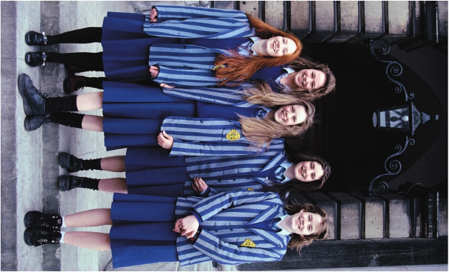

COMPLETE PET FOR SCHOOLS © CAMBRIDGE UNIVERSITY PRESS 2010 THIS PAGE MAY BE PHOTOCOPIED
1A
1B
6



RECORDING SCRIPT

THERE ARE FOUR PARTS TO THE TEST. YOU WILL HEAR
EACH PART TWICE.
FOR EACH PART THERE WILL BE TIME FOR YOU TO
LOOK THROUGH THE QUESTIONS AND TIME FOR YOU
TO CHECK YOUR ANSWERS.

PART 1
There are seven questions in this part.
For each question there are three pictures and a
short recording. For each question, choose the
correct answer (A, B or C).
Before we start, here is an example.

Where did the girl and her family go on holiday?
Boy: Where did you and your family go on
holiday?
Girl: Well, we all wanted to drive to the
mountains – we love it there. But it
started raining heavily on the way, so
Mum thought we’d have to go to the
nearest town and stay there instead.
We weren’t even near a beach or
anything...
Boy: Well, you couldn’t go there in the rain,
anyway...
Girl: No – but then luckily the weather
suddenly improved, so we drove on to
where we’d wanted to go after all!
Boy: Great!
[pause]
The answer is A.
Look at the three pictures for question 1 now.
[pause]

Now we are ready to start. Listen carefully. You will
hear each recording twice.

One. Which cyclist won the race?
Man: That was a great cycle race! I never
expected they’d cycle so fast –
especially the one in the shirt with spots
on.
Girl: Yes, he was in front of the others for
ages – it’s a shame he had a problem
with his bike.
Man: Yes, then the one in the white shirt
passed him – and he looked good until
he was overtaken by the winner.
Girl: Mmm, the one in the plain black shirt –
he was amazingly fast.
[pause]
Now listen again.
[The recording is repeated]
[pause]

Two. Why couldn’t the girl go to photography club
yesterday?
Man: Where were you yesterday, Maria? We
were expecting you at photography
club!
Girl: Well, I had to go shopping for my mum
first, but I was still back in time to get to
photography. But then my mum’s sister
came – we hadn’t seen her for ages, so
my mum wanted me to stay at home.
Man: Right. So what about next time?
Girl: Let’s see – we had a hockey match
against another school last week,
and we’re playing a return match that
evening, but it’ll be over by the time
photography club starts.

[pause]
Now listen again.
[The recording is repeated]
[pause]

COMPLETE PET FOR SCHOOLS © CAMBRIDGE UNIVERSITY PRESS 2010 THIS PAGE MAY BE PHOTOCOPIED
1



Three. Where will the boy and his friend practise
basketball?
Boy: Our team’s got a basketball match
tomorrow, and my friend Sam and I
need some extra practice. The school
gym is closed today, though.
Girl: Well, you could always go to the park.
There’s a net there, and you’d have
plenty of space. Or Mum says you can
use the net Dad put up here in our
garden, just by the house. That’d be
easier.
Boy: Mmm – you’re right. I think the park’s
too far away.
Girl: Give Sam a call then, and ask him to
come.
Boy: OK.
[pause]
Now listen again.
[The recording is repeated]
[pause]

Four. How did the girl get to school?
Boy: Hi, Zoe! I thought you were going to
be late to school! Was the school bus
delayed again?
Girl: Well, someone said there were lots of
people on it, but I wouldn’t know – I
wasn’t on it. I finally got my bike out this
morning...
Boy: Really? Well, you’ve said for ages you
wanted to come to school on it.
Girl: Mmm, but in the end my dad had to
drive me instead – when I tried to ride
my bike, the brakes didn’t work!
Boy: Oh!
[pause]
Now listen again.
[The recording is repeated]

Five. Which music poster does the boy prefer?
Girl: You’ve got some amazing music posters
on your wall, Jamie. I really love that one
of the guitarist.
Boy: Yeah, it’s from a concert I went to with
my older brother. And that one’s of
a drummer he likes – not my choice,
really, but it’s OK.
Girl: And who’s the singer? I don’t recognise
him at all.
Boy: Nor me – my sister gave me it. Hmm...
to be honest, I think I’ll just keep that
poster you like on the wall, and take the
other two down – I’m not so keen on
them.
[pause]
Now listen again.
[The recording is repeated]
[pause]

Six. Where will they go after the cinema?
Girl 1: I’ve got the cinema tickets – the film’s
at 2.30 this afternoon. What shall we do
when it’s finished? We could have a hot
chocolate at the cafe...
Girl 2: That’d be nice, but I’ve got to get some
information for my school project before
I go home.
Girl 1: OK, I’ll come and help you in the library
if you want. I was going to return a CD
to the music shop but we could come
back tomorrow to do that.
Girl 2: OK – we could go for a hot chocolate
afterwards tomorrow.
Girl 1: Great!
[pause]
Now listen again.
[The recording is repeated]
[pause]

[pause]

COMPLETE PET FOR SCHOOLS © CAMBRIDGE UNIVERSITY PRESS 2010 THIS PAGE MAY BE PHOTOCOPIED
2




Seven. What will Sam take on the school museum
trip tomorrow?
[phone message]
Boy: Hi, Harry, it’s Sam, with a message for
you about tomorrow’s trip. I’ve bought
a new memory card for my camera,
but I think you’re taking yours, aren’t
you? So I’ll leave mine at home – I’ll be
responsible for pens and paper instead!
I know our teacher wants us to take
notes inside the museum. And why
don’t you ask Max to bring the textbook
we have to take – we only need one
between us, and it’s really heavy...
[pause]
Now listen again.
[The recording is repeated]
[pause]
That is the end of Part 1.
[pause]

PART 2
Now turn to Part 2, questions 8–13.
You will hear an interview with a student called
Sarah Mercer, who is planning to become a
weather forecaster.
For each question, put a tick in the correct box.
You now have 45 seconds to look at the questions
for Part 2.
[pause]
Now we are ready to start. Listen carefully. You will
hear the recording twice.
Interviewer: In our series on careers, I’m talking to
college student Sarah Mercer, who
wants to become a weather forecaster.
Sarah, when did you become interested
in weather?
Sarah: Well, I could actually read a weather
map when I was ten! I remember we
had really cold winters in my home town
that made travelling difficult, so I’d

switch on the TV forecast to see when
we’d have good weather. My science
teacher was surprised how much I
knew during our lessons on weather at
school!
Interviewer: And did your family encourage you?
Sarah: My grandfather recorded the weather
every day, but I was too young to
remember that. It probably influenced
my father, though - he became a
science teacher. But my mum bought
me special notebooks to record the
weather, just like my grandfather had
done, and those helped me a lot.
Interviewer: And you started a weather club at your
school. What happened there?
Sarah: Well, my teacher asked me to help other
pupils learn about the weather, so I
started the club. The school already
had a mini weather station, so we used
what we found out from that to put
in a daily weather diary – that’s now
kept in the school library. And I found
the information very useful for school
projects I worked on!
Interviewer: And your family’s hobby is sailing, isn’t
it? Have you had any bad experiences
with weather on your trips?
Sarah: Well, one day we went sailing when
the forecast that morning was for good
weather. But we didn’t listen to it again
later, which you should always do,
because it changed, and we got caught
in a storm. At least we were wearing
our wet-weather clothes! But now I
always watch the clouds to see if bad
weather’s on the way.
Interviewer: So what kind of job will you have in the
future?
Sarah: My friends think I’m doing this to
get a job as a TV weather presenter,
but I’d be too nervous for that! But
I’m attracted by the idea of going to
different countries to work. And

COMPLETE PET FOR SCHOOLS © CAMBRIDGE UNIVERSITY PRESS 2010 THIS PAGE MAY BE PHOTOCOPIED
3




there are good jobs working with
international sailing teams, but I’m not
sure if that’s for me.
Interviewer: So finally, Sarah – what’s your favourite
weather?
Sarah: Well, everyone likes it when it’s sunny,
and I do, too, but when it’s pouring
down outside you get great grey clouds
that are really beautiful, so I usually rush
out in the wet! Fog is interesting, too,
the way it suddenly appears, but it’s a
bit dangerous, so I can’t say I really like
it.
Interviewer: Thanks, Sarah.
[pause]
Now listen again.
[The recording is repeated]
[pause]
That is the end of Part 2.
[pause]

PART 3
Now turn to Part 3, questions 14–19.
You will hear an art teacher talking to a class about
a design competition run by an online magazine.
For each question, fill in the missing information in
the numbered space.
You now have 20 seconds to look at Part 3.
[pause]
Now we are ready to start. Listen carefully. You will
hear the recording twice.
Art teacher:Now listen, everyone. Before we get
started on our lesson today I’ve got an
announcement. It’s about a competition
I think some of you might be interested
in entering. It’s run by a young people’s
internet magazine called Creative
Designs and they’re inviting you to

magazine. Some of you took part
last year, didn’t you? I remember you
designed a poster. Well, this time
they’re asking you for something
different – a T-shirt! They say it can
look however you want it to – you can
choose the colour, and the words you
put on it. The only thing is, it must have
a picture somewhere on it. You must
include that in your design. It could
be one you’ve produced yourself, or
one you’ve found – we’ll work on ideas
for that together. Now, if you want to
enter the competition, you need to get
organised, because the final date’s quite
soon – they’ll be announcing who’s won
on 27th May, so your designs need to
get to them by 9th. That gives them
two weeks to look through all your
work! There are some other things you
should send in with your work, too. Of
course, you’ll have to send your name
and address, and also the name of your
art teacher. But they also say if you can,
it’s good to send your photo – and I
guess if you’ve got one of you and your
design, that’s great! If you’re one of
the winners, you’ll get a drawing book
and pens, and a book on design – very
useful for your studies. And as a school,
we’ll get a DVD player! Of course, you’ll
also get to see your design on the
website! So if you want to look on the
website, then here’s the address – it’s
www...
[pause]
Now listen again.
[The recording is repeated]
[pause]
That is the end of Part 3.
[pause]

design something for their internet

COMPLETE PET FOR SCHOOLS © CAMBRIDGE UNIVERSITY PRESS 2010 THIS PAGE MAY BE PHOTOCOPIED
4



PART 4
Now turn to Part 4, questions 20–25.
Look at the six sentences for this part.
You will hear a boy called Mark and a girl called
Anna talking about winter sports.
Decide if each sentence is correct or incorrect.
If it is correct, choose the letter A for YES. If it is
not correct, choose the letter B for NO.
You now have 20 seconds to look at the questions
for Part 4.
[pause]
Now we are ready to start. Listen carefully. You will
hear the recording twice.
Anna: Hi, Mark! How was your winter sports
trip?
Mark: It was OK, thanks, Anna. We went to a
different holiday centre this time. There
wasn’t as much snow as we’d expected,
but luckily there was still enough to try
snowboarding!
Anna: So was it the first time you’d done it?
Mark: Mmm, but my older brother had been
before, so he hired some equipment for
me and we went up the slopes. I was
soon doing a few jumps and things.
Anna: Really? I remember the first time I went
– it took me ages to snowboard well!
Mark: One thing I found, though, was that my
surfing really helped me to balance.
And I’m pretty fit now, too. Still, my
brother isn’t so fit, but he still managed
some pretty good snowboarding too.

Anna: That’s right.
Mark: Talking of professionals, I saw one
doing some amazing snowboarding
moves at a show there – doing Big Airs
and things...
Anna: Really?
Mark: Mmm. And of course, other people
who weren’t really skilled enough were
copying him. I wouldn’t try it – I’m
happy just doing the things I can do!
Anna: Yeah, me too. So will you go skiing or
snowboarding on your next holiday?
Mark: Well, the snowboarding was certainly
great fun! I’ve reached a good level in
skiing, though, and I want to keep it up
– so if there’s snow, I’d rather do that
than anything else.
Anna: I know what you mean. I’m going to
concentrate on skiing from now on, too.
[pause]
Now listen again.
[The recording is repeated]
[pause]
That is the end of Part 4.
[pause]
You now have six minutes to check and copy your
answers on to the answer sheet.
[pause]
You have one more minute.
[pause]
That is the end of the test.

Anna: That’s good. And did you wear a hard
hat and so on, to protect yourself? My
mum always made me do that, then I fell
over pretty hard last time we went and
I understood why. But then I still saw
lots of people wearing unsuitable stuff.
It’s dangerous – I just don’t understand
why they do it.
Mark: Me neither. The professionals all wear
the right equipment to stop them
getting hurt.

COMPLETE PET FOR SCHOOLS © CAMBRIDGE UNIVERSITY PRESS 2010 THIS PAGE MAY BE PHOTOCOPIED
5

PAPER 1 READING AND WRITING
Reading
PART 1
1B 2C 3A 4C 5B
PART 2
6E 7F 8G 9H 10 B
PART 3
11 B 12 A 13 B 14 B 15 B 16 A 17 A 18 A 19 B 20 B
PART 4
21 B 22 C 23 A 24 D 25 B
PART 5
26 D 27 B 28 A 29 C 30 B 31 A 32 D 33 B 34 D 35 C

WRITING
PART 1
1 have enough 2 took 3 better 4 so many 5 don’t you / don’t we / not
PART 2, QUESTION 6
Answer must contain the three content points:
1 description of what kind of book was bought
2 explanation of why the candidate chose the book
3 suggestion as to when the candidate can show their English friend what they bought

PAPER 2 LISTENING
PART 1
1A 2C 3B 4C 5A 6C 7B
PART 2
8B 9A 10 A 11 C 12 C 13 B
PART 3
14 Creative/creative 15 T-shirt 16 picture 17 9(th) 18 photo 19 DVD player
PART 4
20 B 21 A 22 B 23 A 24 B 25 B

COMPLETE PET FOR SCHOOLS © CAMBRIDGE UNIVERSITY PRESS 2010 THIS PAGE MAY BE PHOTOCOPIED

ACKNOWLEDGEMENTS

The authors and publishers acknowledge the following sources of copyright material and are grateful
for the permissions granted. While every effort has been made, it has not always been possible to
identify the sources of all the material used, or to trace all copyright holders. If any omissions are
brought to our notice, we will be happy to include the appropriate acknowledgements on reprinting.

The PUBLISHERS ARE GRATEFUL TO THE FOLLOWING FOR PERMISSION TO INCLUDE COPYRIGHT PHOTOGRAPHS
AND OTHER ILLUSTRATION MATERIAL:

Key: l = left, c = centre, r = right, t = top, b = bottom, u = upper, lo = lower, f = far.

Alamy/©imagebroker p 6 (paper 1), /©Ken Weingart p 3 (paper 1 t); Corbis/©Rose Hartman
p 6 (paper 3 part 2 t), /©Tim Pannell p 7 (paper 1); Getty Images/Photographer's Choice/Richard Ross
p 3 (paper 1 c), /Riser/Sara Wight p 3 (paper 1 b), /Taxi/Ricky John Molloy p 3 (paper 1 uc);
Rex Features p 6 (paper 3 part 2 b). Shutterstock Images/Monkey Business Images p 3 (paper 1 loc).

Picture Research by Hilary Fletcher

Kveta from the Three In A Box agency (paper 2 pages 1, 2, 3); (paper 3, page 4).

Cambridge University Press would also like to thank Martin Goldman (audio producer),
Alison Ramsey (copy editor) and Kevin Doherty (proof-reader).

COMPLETE PET FOR SCHOOLS © CAMBRIDGE UNIVERSITY PRESS 2010 THIS PAGE MAY BE PHOTOCOPIED
7

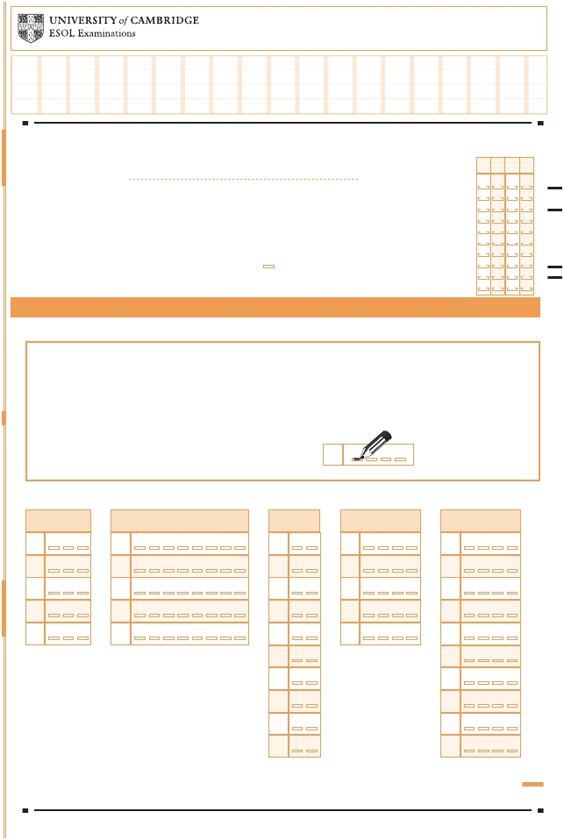
SAMPLE
Part 5
26 | A B C D
27 | A B C D
28 | A B C D
29 A B C D
30 A B C D
31 | A B C D
32 | A B C D
33 A B C D
34 A B C D
35 | A B C D

Part 2
6 | A B C D E F G H
7 | A B C D E F G H
8 | A B C D E F G H
9 | A B C D E F G H
10 | A B C D E F G H

Part 4
21 | A B C D
22 | A B C D
23 | A B C D
24 | A B C D
25 | A B C D

Part 1
1 | A B C
2 | A B C
3 | A B C
4 | A B C
5 | A B C

Candidate Name
If not already printed, write name
in CAPITALS and complete the
Candidate No. grid (in pencil).
Candidate Signature

Centre No.

Candidate No.

0
0
0
0

Examination Title
Centre

Supervisor:
If the candidate is ABSENT or has WITHDRAWN shade here
Examination
Details
1
2
3
4
5
6
7
8
9
1
2
3
4
5
6
7
8
9
1
2
3
4
5
6
7
8
9
1
2
3
4
5
6
7
8
9

PET Paper 1 Reading and Writing Candidate Answer Sheet 1

Instructions
Use a PENCIL (B or HB).
Rub out any answer you want to change with an eraser.
For Reading:
Mark ONE letter for each question.

For example, if you think A is the right answer to the
question, mark your answer sheet like this:
0 A B C D

Part 3
11 A B
12 A B
13 A B
14 A B
15 A B
16 A B
17 A B
18 A B
19 A B
20 A B

Continue on the other side of this sheet

PET RW 1 DP491/389

REPRODUCED WITH THE PERMISSION OF CAMBRIDGE ESOL


SAMPLE
0 1 2 3 4 5 6 7 8 9
0 1 2 3 4 5 6 7 8 9
0 1 2 3 4 5 6 7 8 9
0 1 2 3 4 5 6 7 8 9

0 | 0 | 0 | 0
1 | 1 | 1 | 1
2 | 2 | 2 | 2
3 | 3 | 3 | 3
4 | 4 | 4 | 4
5 | 5 | 5 | 5
6 | 6 | 6 | 6
7 | 7 | 7 | 7
8 | 8 | 8 | 8
9 | 9 | 9 | 9

Candidate Name
If not already printed, write name
in CAPITALS and complete the
Candidate No. grid (in pencil).
Candidate Signature

Examination Title

Centre No.

Candidate No.

Examination

Details
Centre

Supervisor:
If the candidate is ABSENT or has WITHDRAWN shade here

PET Paper 1 Reading and Writing Candidate Answer Sheet 2

Candidate Instructions:

Write your answer to Writing Part 3
on the other side of this sheet.

Use a PENCIL (B or HB).

This section for use by FIRST Examiner only
Mark:

0 1.1
1.2 1.3 2.1 2.2 2.3 3.1 3.2 3.3 4.1 4.2 4.3 5.1 5.2 5.3

Examiner Number:

PET RW 2 DP492/390

REPRODUCED WITH THE PERMISSION OF CAMBRIDGE ESOL


For Writing (Parts 1 and 2):
Part 1: Write your answers below. |  | Do not  write here
1 |  | 1 1 0  1 2 0  1 3 0  1 4 0  1 5 0
2 |  | 1 1 0  1 2 0  1 3 0  1 4 0  1 5 0
3 |  | 1 1 0  1 2 0  1 3 0  1 4 0  1 5 0
4 |  | 1 1 0  1 2 0  1 3 0  1 4 0  1 5 0
5 |  | 1 1 0  1 2 0  1 3 0  1 4 0  1 5 0

SAMPLE

Write your answers clearly in the spaces provided.

Part 2 (Question 6): Write your answer below.

Put your answer to Writing Part 3 on Answer Sheet 2

Do not write below (Examiner use only).

0 1

REPRODUCED WITH THE PERMISSION OF CAMBRIDGE ESOL
2 3 4 5


Q7 Q8
0 1 2 3 4 5 6 7 8 9
0 1 2 3 4 5 6 7 8 9
0 1 2 3 4 5 6 7 8 9
0 1 2 3 4 5 6 7 8 9

SAMPLE
Part 3: Mark the number of the question you are answering here or
Write your answer below.

Do not write below this line

This section for use by SECOND Examiner only
Mark:
0 1.1 1.2 1.3 2.1 2.2 2.3 3.1 3.2 3.3 4.1 4.2 4.3 5.1 5.2 5.3

Examiner Number:

REPRODUCED WITH THE PERMISSION OF CAMBRIDGE ESOL

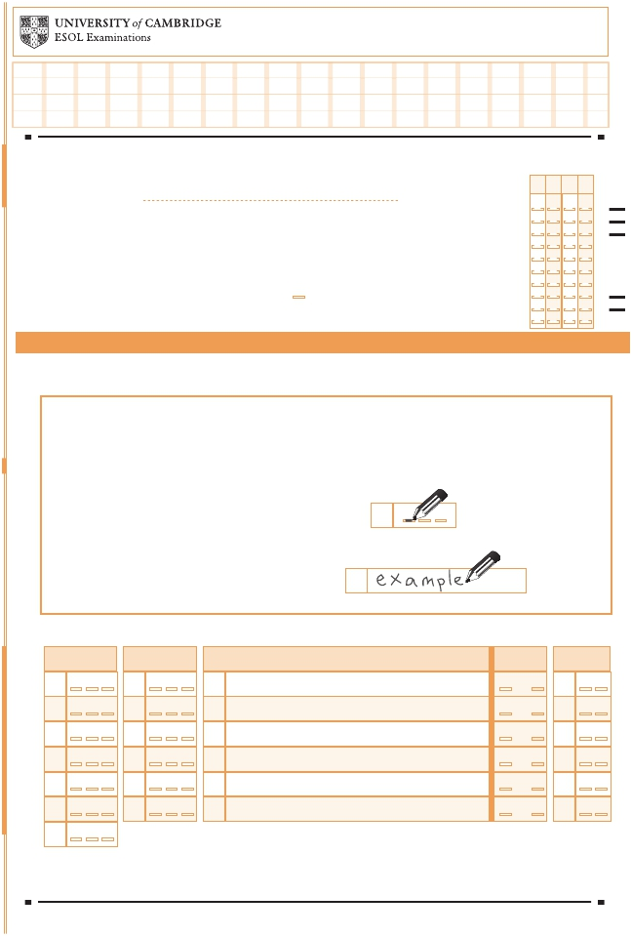
SAMPLE
Part 3 |  | Do not  write here
14 |  | 1 14 0
15 |  | 1 15 0
16 |  | 1 16 0
17 |  | 1 17 0
18 |  | 1 18 0
19 |  | 1 19 0

Part 1
1 | A B C
2 | A B C
3 | A B C
4 A B C
5 | A B C
6 | A B C
7 | A B C

Part 2
8 | A B C
9 | A B C
10 | A B C
11 | A B C
12 | A B C
13 | A B C

Part 4
20 | A B
21 | A B
22 | A B
23 | A B
24 | A B
25 | A B

Candidate Name
If not already printed, write name
in CAPITALS and complete the
Candidate No. grid (in pencil).
Candidate Signature

Centre No.

Candidate No.

0
0
0
0

Examination Title
Centre

Supervisor:
If the candidate is ABSENT or has WITHDRAWN shade here
Examination
Details
1
2
3
4
5
6
7
8
9
1
2
3
4
5
6
7
8
9
1
2
3
4
5
6
7
8
9
1
2
3
4
5
6
7
8
9

PET Paper 2 Listening Candidate Answer Sheet

You must transfer all your answers from the Listening Question Paper to this answer sheet.

Instructions
Use a PENCIL (B or HB).
Rub out any answer you want to change with an eraser.
For Parts 1, 2 and 4:
Mark ONE letter for each question.

For example, if you think A is the right answer to the
question, mark your answer sheet like this:

For Part 3:
Write your answers clearly in the spaces next
to the numbers (14 to 19) like this:

0
0 A B C

PET L DP493/391

REPRODUCED WITH THE PERMISSION OF CAMBRIDGE ESOL

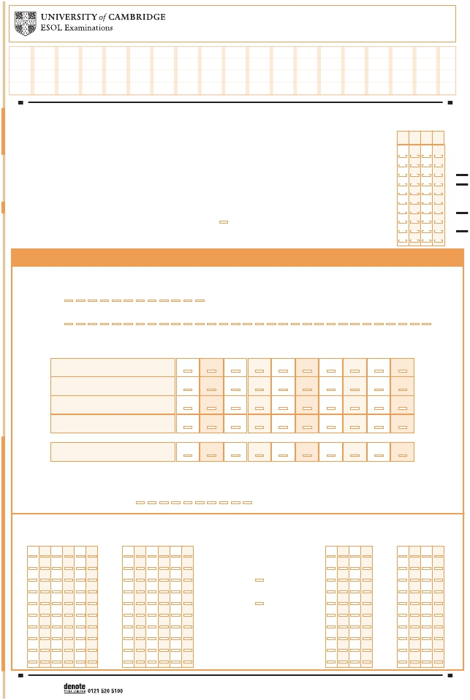
SAMPLE
Grammar and Vocabulary | 0 | 1.0 | 1.5 | 2.0 | 2.5 | 3.0 | 3.5 | 4.0 | 4.5 | 5.0
Discourse Management | 0 | 1.0 | 1.5 | 2.0 | 2.5 | 3.0 | 3.5 | 4.0 | 4.5 | 5.0
Pronunciation | 0 | 1.0 | 1.5 | 2.0 | 2.5 | 3.0 | 3.5 | 4.0 | 4.5 | 5.0
Interactive Communication | 0 | 1.0 | 1.5 | 2.0 | 2.5 | 3.0 | 3.5 | 4.0 | 4.5 | 5.0

Candidate Name
If not already printed, write name
Centre No.

in CAPITALS and complete the
Candidate No. grid (in pencil).
Candidate No.

0
0
0
0

Examination Title
Centre

Supervisor:
If the candidate is ABSENT or has WITHDRAWN shade here
Examination
Details
1
2
3
4
5
6
7
8
9
1
2
3
4
5
6
7
8
9
1
2
3
4
5
6
7
8
9
1
2
3
4
5
6
7
8
9

PET Paper 3 Speaking Mark Sheet
Date of test:

Month

Day
01 02 03 04 05 06 07 08 09 10 11 12

01 02 03 04 05 06 07 08 09 10 11 12 13 14 15 16 17 18 19 20 21 22 23 24 25 26 27 28 29 30 31

Marks awarded:

Global Achievement

0

1.0

1.5

2.0

2.5

3.0

3.5

4.0

4.5

5.0

Test materials used: 1 2 3 4 5 6 7 8 9 10

Assessor’s
number

Interlocutor’s
number

Test format

Number of
2nd Candidate

Number of
3rd Candidate

A A 0
B B 1
0 A A
1 B B
A A 0
B B 1
0 A A Examiners : Candidates
1 B B
0
1
0
1
0
1
0
1
0
1
0
1
0
1
0
1

C C 2
D D 3
E E 4
2 C C
3 D D
4 E E
C C 2
D D 3
E E 4
2 C C
3 D D
4 E E
2:2

2:3
2
3
4
2
3
4
2
3
4
2
3
4
2
3
4
2
3
4
2
3
4
2
3
4

F F
5
5
F F
F F
5
5
F F
5
5
5
5
5
5
5
5

G G 6
H H 7
6 G G
7 H H
G G 6
H H 7
6 G G
7 H H
6
7
6
7
6
7
6
7
6
7
6
7
6
7
6
7

J
J
8
8
J
J
J
J
8
8
J
J
8
8
8
8
8
8
8
8

K K 9
9 K K
K K 9
9 K K
9
9
9
9
9
9
9
9

PET S DP383/332

REPRODUCED WITH THE PERMISSION OF CAMBRIDGE ESOL

