Відповіді

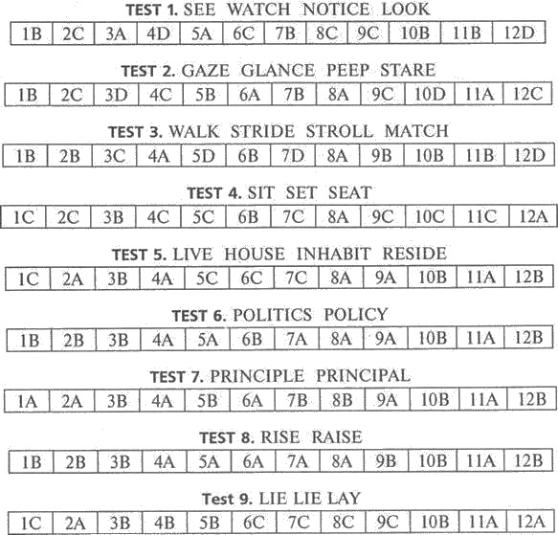

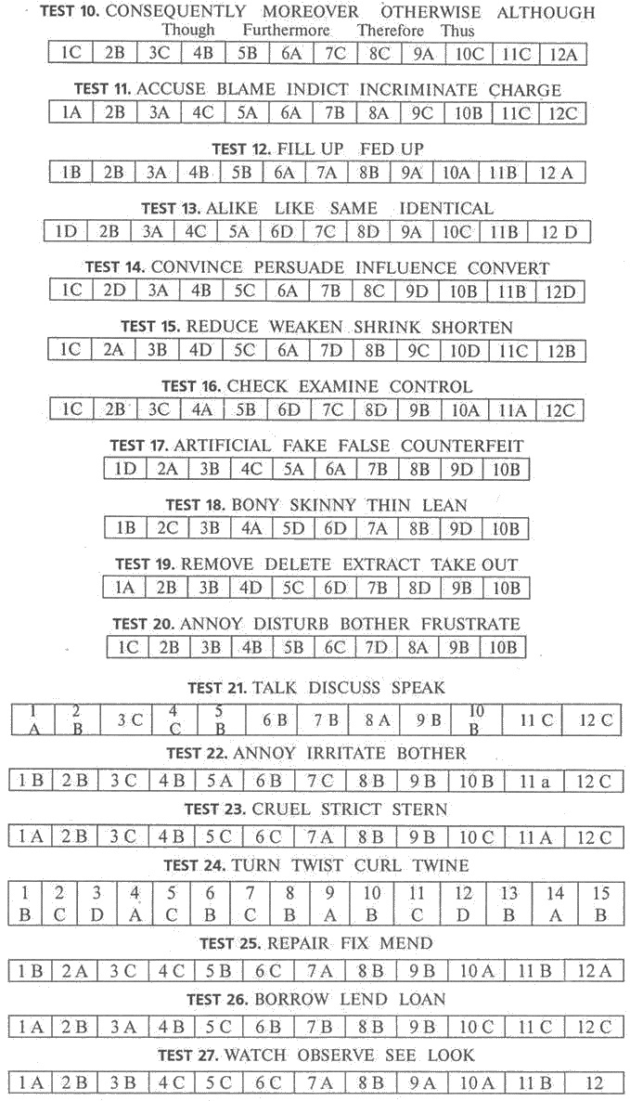
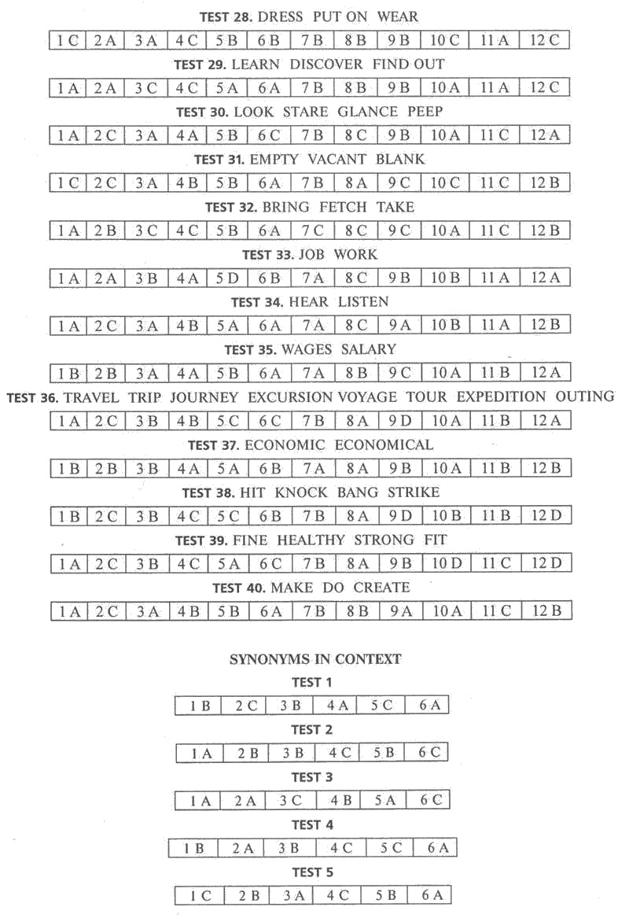
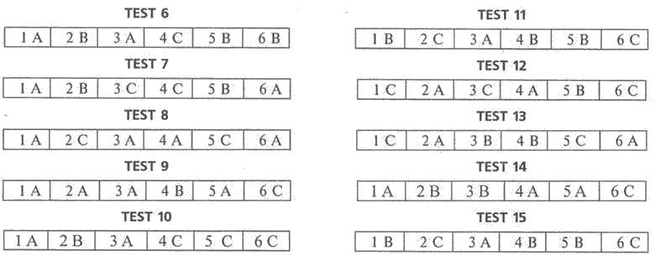

PHRASAL VERBS

TEST 1. BREAK
1 | broke down
2 | broke up
3 | broke in
4 | broke out
5 | break in
6 | broke down
7 | broke up
8 | broke out

TEST 2. COME
1 | coming out
2 | come down
3 | come round
4 | came across
5 | came down
6 | come out

TEST 3. GIVE
1 | gave up
2 | give away
3 | gave out
4 | gave in
5 | gave up
6 | giving away
7 | gave up
8 | gave out

TEST 4. LOOK
1 | look after
2 | looking forward
3 | Look out
4 | look...up
5 | looking for
6 | look up
7 | Look out
8 | looking for
9 | look after
10 | looking for

TEST 5. MAKE
1 | make for
2 | make out
3 | make up for
4 | made up
5 | make out
6 | made for
7 | make up for
8 | make out

TEST 6. PICKS
1 | picks... up
2 | picked at
3 | picked out
4 | picked on
5 | picked... up
6 | picked out
7 | picked at
8 | picked on

TEST 7. TAKE

1 | takes up
2 | take off
3 | taking... out
4 | take after
5 | take ... out
6 | takes off
7 | takes after
8 | takes up

TEST 8. TURN
1 | Turn ... off
2 | Turn ... on
3 | Turn ... up
4 | turned into
5 | Turn ... down
6 | turned down
7 | turn down
8 | turned into

TEST 9. HANG
1 | hung back
2 | hanging around
3 | hang back
4 | hang up
5 | hanging up
6 | hang together
7 | hang up
8 | hung around

TEST 10. PAY
1 | pay back
2 | pay ... back
3 | paid off
4 | pay out
5 | pay out
6 | paid down

TEST 11. GET
1 up | 2 on | 3 back | 4 up | 5 back | 6 on
7 at | 8 back | 9 around | 10 around | 11 on | 12 at

TEST 12. GO
1 into | 2 through | 3 along | 4 on | 5 about | 6 on
7 into | 8 on | 9 along | 10 about | 11 | 12

TEST 13. MAKE
1 over | 2 up | 3 off | 4 over | 5 up | 6 for
7 over | 8 out | 9 up | 10 up | 11 out | 12 for

TEST 14. PUT
1 up with | 2 on | 3 off | 4 away | 5 on | 6 up with
7 on | 8 on | 9 away | 10 on | 11 in | 12 off

TEST 15. SEE
1 about | 2 over | 3 through | 4 off | 5 about | 6 off
7 about | 8 over | 9 about | 10 through | 11 | 12

TEST 16. STAND
1 up | 2 out | 3 out | 4 by | 5 by | 6 about
7 around | 8 by | 9 up | 10 up | 11 | 12

TEST 17. WEAR
1 down | 2 out | 3 off | 4 down | 5 off | 6 out
7 off | 8 down | 9 off | 10 out | 11 | 12

TEST 18. WORK
1 up | 2 on | 3 out | 4 up | 5 out | 6 through
7 out | 8 on | 9 out | 10 out | 11 on | 12 out

TEST 19. SET
1 up | 2 up | 3 up | 4 up | 5 off | 6 up
7 out | 8 out | 9 out | 10 about | 11 out | 12 off

TEST 20. KEEP
1 in | 2 up | 3 in | 4 up | 5 from | 6 up
7 on | 8 up | 9 up | 10 on | 11 | 12

GRAMMAR GRAMMAR TENSES IN CONTEXT

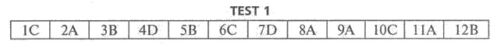
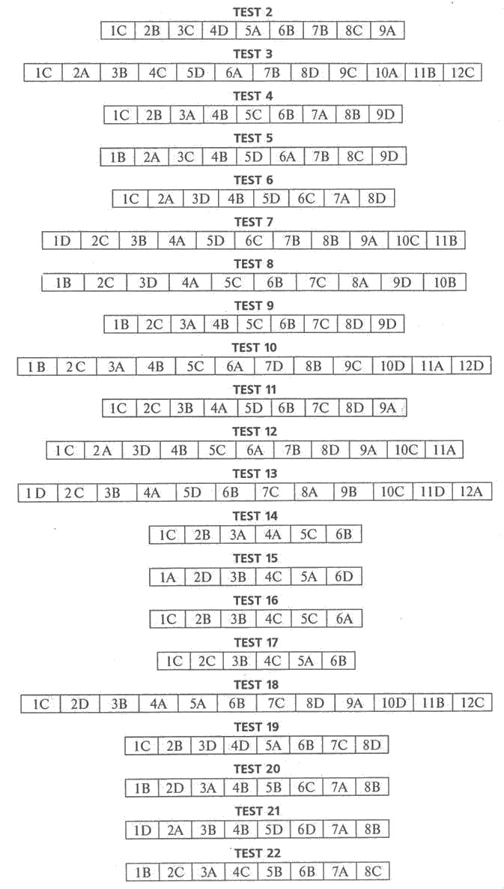
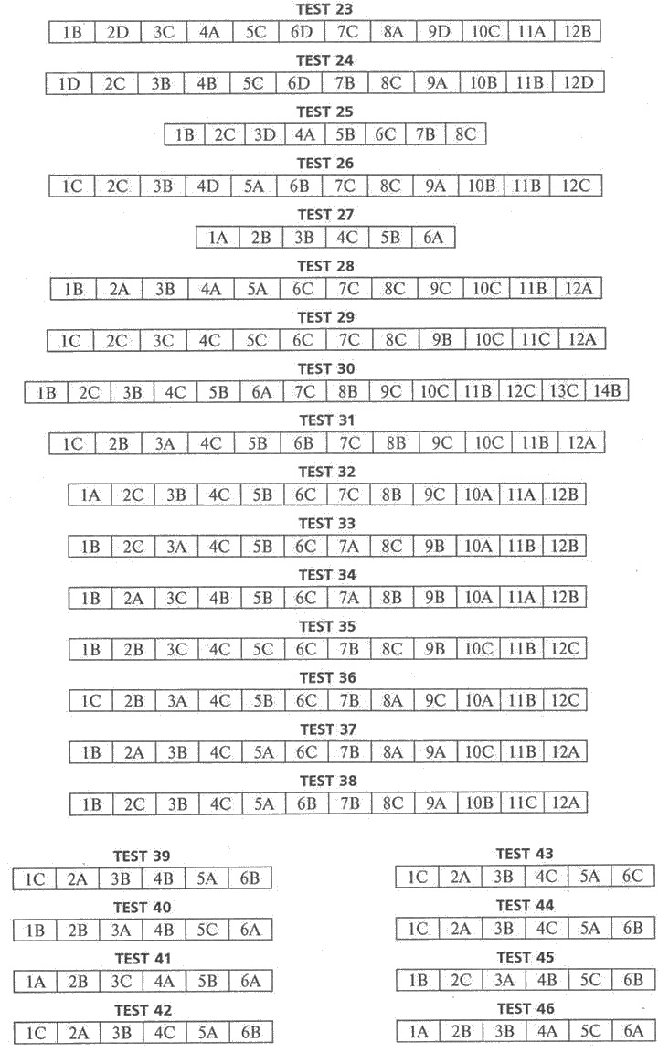
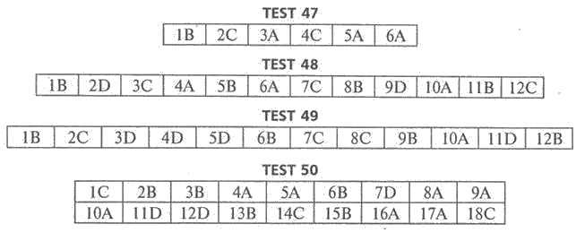

SITUATIONAL GRAMMAR

TEST 1
1 | am working
2 | is talking
3 | is studying
4 | wants
5 | is learning
6 | work
7 | am working
8 | is

TEST 2
1 | will come
2 | is
3 | is planning
4 | will plant
5 | will plant
6 | is
7 | will enjoy

TEST 3
1 | has moved
2 | is
3 | am
4 | will find
5 | will introduce

TEST 4
1 | has
2 | collects
3 | p class=MsoNormal style='text-align:justify;text-indent:18.1pt'>does your brother collect
4 | has
5 | has travelled
6 | takes
7 | will see
8 | will certainly come

TEST 5
1 | am working
2 | is open
3 | know
4 | are paying
5 | Do you like
6 | am having
7 | are
8 | am wearing
9 | is always telling
10 | doesn’t seem

TEST 6
1 | was | 6 | couldn’t find | 11 | finished
2 | was | 7 | walked | 12 | went
3 | got up | 8 | was | 13 | had
4 | didn’t have | 9 | had | 14 | didn’t want
5 | was | 10 | was | 15 | went

TEST 7
1 | looked
2 | walked
3 | stopped
4 | asked
5 | said
6 | told
7 | called
8 | arrived
9 | saw
10 | believed
11 | ran

TEST 8
1 | was | 6 | couldn’t | 11 | finished
2 | was | 7 | rode | 12 | went
3 | got up | 8 | was | 13 | had
4 | was | 9 | had | 14 | didn't want
5 | didn’t have | 10 | was | 15 | went

TEST 9
1 | has been
2 | was
3 | made
4 | was
5 | has made
6 | has taken
7 | has been
8 | visited
9 | have been
10 | bought
11 | have lived

TEST 10
1 | has become
2 | took
3 | was
4 | have changed
5 | have never visited
6 | have travelled
7 | went
8 | visited
9 | spent
10 | hiked

TEST 11
1 | have discovered
2 | has raised
3 | found
4 | is
5 | is
6 | has
7 | observed
8 | exists

TEST 12
1 | were driving
2 | saw
3 | thought
4 | has been
5 | am taking
6 | drove away
7 | returned
8 | had taken
9 | are taking

TEST 13
1 | were arguing
2 | entered
3 | are you arguing
4 | have found
5 | have decided
6 | will tell
7 | was
8 | didn’t know
9 | was
10 | gave

TEST 14
1 | have been drinking
2 | appeared
3 | were followed
4 | came
5 | is
6 | dates
7 | handed
8 | converted

TEST 15
1 | have been waiting
2 | have given up
3 | stops
4 | is
5 | has
6 | twitch
7 | crouches
8 | pounces
9 | emerges
10 | appeared

TEST 16
1 | has named | 7 | began
2 | was | 8 | stated
3 | told | 9 | gathered
4 | gave | 10 | received
5 | made | 11 | were
6 | were | 12 | shocked

TEST 17
1 | was | 6 | saw | 11 | pulled
2 | was | 7 | looked | 12 | started
3 | heard | 8 | had seen | 13 | was
4 | shouted | 9 | felt | 14 | remembered
5 | was | 10 | ran | 15 | were

TEST 18
1 | peeped | 11 | died
2 | was | 12 | struck
3 | heard | 13 | was
4 | were getting | 14 | went
5 | was | 15 | tried
6 | knew | 16 | felt
7 | kept | 17 | sat
8 | ran | 18 | was
9 | took | 19 | passed
10 | started | 20 | fell

TEST 19
1 | woke up | 11 | could
2 | decided | 12 | remembered
3 | found | 13 | did not use
4 | measured | 14 | reached
5 | found | 15 | told
6 | ended | 16 | started
7 | went | 17 | started
8 | saw | 18 | told
9 | was | 19 | had dressed up
10 | were | 20 | was

TEST 20
1 | is playing | 11 | has been
2 | sell | 12 | is flying
3 | has, missing | 13 | was
4 | is | 14 | was
5 | have | 15 | were

TEST 21
1 | have just received
2 | haven't heard
3 | have been
4 | are doing
5 | move
6 | drift

TEST 22
1 | are moving
2 | am going
3 | keep
4 | to drop
5 | settle down
6 | will keep
7 | Do you have
8 | hearing

TEST 23
1 | turns
2 | is always making
3 | always makes
4 | don’t you have
5 | didn’t work
6 | did you try
7 | am going
8 | be evicted

TEST 24
1 | to share
2 | feeding
3 | to have
4 | to reimburse
5 | freeloading
6 | come up
7 | treats
8 | to have
9 | to mend
10 | to move out
11 | wear

TEST 25

1 | to have
2 | to choose
3 | could
4 | to lose
5 | to have
6 | don’t tempt
7 | doing
8 | not tempt
9 | might

TEST 26
1 | Have you been working out
2 | have been going
3 | look
4 | Have you been lifting
5 | do
6 | feel
7 | look

TEST 27
1 | look
2 | have been feeling
3 | caught
4 | haven’t got(ten)
5 | Don’t you want
6 | to be over
7 | don’t want

TEST 28
1 | am running
2 | is spinning
3 | feels
4 | have
5 | stay
6 | don’t work
7 | has obviously played
8 | guess
9 | to keep
10 | quit
11 | don’t want

TEST 29
1 | is it going
2 | am
3 | is giving
4 | see
5 | did the doctor say
6 | to relax
7 | relaxing
8 | to get worse
9 | relax

TEST 30
1 | to order
2 | will have
3 | do you want
4 | to drink
5 | Do you have
6 | would you like

GRAMMAR IN USE

TEST 1
1 | was roaming
2 | to remain
3 | peeped
4 | are you doing
5 | have ever tasted
6 | thinking
7 | quenched
8 | will climb
9 | will help
10 | to understand
11 | walking
12 | would never have got in

TEST 2
1 | were cycling
2 | lost
3 | crying
4 | getting up
5 | bandaged
6 | hearing
7 | came
8 | was scared
9 | am afraid
10 | am eating
11 | Didn’t ... say
12 | keeps

TEST 3
1 | retired
2 | had to find
3 | were
4 | was
5 | was
6 | to disturb
7 | was
8 | dived
9 | took
10 | was
11 | had placed
12 | was chosen

TEST 4
1 | taking
2 | coming out
3 | neighbour’s
4 | was
5 | to hear
6 | called
7 | to get
8 | to break
9 | was spreading
10 | put out
11 | were very sad
12 | saving
TEST 5
1 | were not
2 | was feeling
3 | to go
4 | left
5 | had left
6 | searching
7 | to leave
8 | standing
9 | growling
10 | to pounce
11 | returned
12 | to calm down

TEST 6
1 | had put up
2 | collecting
3 | felt
4 | to drown
5 | was sitting
6 | went
7 | dropped
8 | was caught
9 | was sitting
10 | was hovering
11 | stung
12 | was saved

TEST 7
1 | was sleeping
2 | Taken aback
3 | get
4 | was taken
5 | leaving
6 | not to sleep
7 | re-visited
8 | was lying
9 | Seeing
10 | be
11 | makes
12 | repenting

TEST 8
1 | helps
2 | had
3 | king’s
4 | didn’t believe
5 | would Test
6 | was summoned
7 | was given
8 | was placed
9 | caressed
10 | is
11 | won’t be safe
12 | was highly pleased

TEST 9
1 | lying
2 | Seeing
3 | boy’s
4 | held
5 | could
6 | disappointed
7 | crying
8 | was looking
9 | Don’t be greedy
10 | Be satisfied
11 | will be able
12 | second

TEST 10
1 | to drink
2 | to quench
3 | looked
4 | attacked
5 | bleeding
6 | Feeling
7 | to be fresh
8 | were looking
9 | understand
10 | were waiting
11 | to be killed
12 | became

TEST 11
1 | having
2 | blossomed
3 | is believed
4 | fade
5 | everlasting
6 | have
7 | said
8 | you are
9 | envy
10 | wouldn’t have said
11 | are known
12 | have been cut

TEST 12
1 | was getting married
2 | reached
3 | were happy
4 | have the marriage stalled
5 | to do
6 | will request
7 | croaking
8 | is your problem
9 | Reaching
10 | dries up
11 | gets married
12 | shall send

TEST 13
1 | abounded
2 | to play
3 | playing
4 | felt amused
5 | to pelt
6 | will run
7 | throwing
8 | lost
9 | Seeing
10 | laughed
11 | to stop
12 | ran away

TEST 14
1 | held
2 | to take
3 | to carry
4 | saying
5 | would pierce
6 | running
7 | kill
8 | more mercilessly
9 | will follow
10 | kill
11 | killing
12 | the easiest

TEST 15
1 | flying
2 | was basking
3 | was very dissatisfied
4 | have to make
5 | teach
6 | am fed up
7 | advised
8 | not to go
9 | hasn’t given
10 | didn’t listen
11 | had to agree
12 | felt puffed up

TEST 16
1 | were journeying
2 | To kill
3 | talking
4 | to boast
5 | to be superior
6 | there was
7 | came
8 | stood
9 | strangulating
10 | Doesn’t it prove
11 | shall / will show
12 | had no

TEST 17
1 | were
2 | to be
3 | stronger
4 | hid
5 | seeing
6 | put
7 | hesitation
8 | was sure
9 | to start fighting
10 | Hovering
11 | caught
12 | to feed

TEST 18
1 | was grazing
2 | to save
3 | gained
4 | hid
5 | took
6 | Finding
7 | browsing
8 | caught
9 | had not gone
10 | shot
11 | being ungrateful
12 | started eating

TEST 19
1 | were always quarreling
2 | tried
3 | would never pay attention
4 | was very worried
5 | came across
6 | to bring
7 | brought
8 | to try
9 | failed
10 | to break
11 | keep quarrelling
12 | will be broken

TEST 20
1 | was flying
2 | curled up
3 | was sunbathing
4 | was dead
5 | swooped down
6 | could eat
7 | was trying
8 | bit
9 | proved
10 | dying
11 | had found
12 | knowing

TEST 21
1 | longer
2 | world’s
3 | recommends
4 | do not have
5 | are appropriating
6 | continues
7 | account
8 | is stored
9 | hold
10 | is thought
11 | is covered
12 | will take

TEST 22
1 | celebrated
2 | commemorating
3 | originated
4 | didn't take
5 | encountered
6 | was celebrated
7 | was convened
8 | is
9 | is defined
10 | corresponds
11 | be celebrated
12 | was crucified

TEST 23
1 | is caused
2 | have moved
3 | Earth’s
4 | builds
5 | releasing
6 | be concentrated
7 | less
8 | million
9 | these
10 | are classified
11 | larger
12 | recorded

TEST 24
1 | highest
2 | be found
3 | lies
4 | was built
5 | measured
6 | more
7 | most expensive
8 | was built
9 | world’s
10 | tucked
11 | its
12 | reaches

TEST 25
I | started
2 | westernized
3 | fascinated
4 | starting
5 | had invited
6 | built
7 | named
8 | sent
9 | men
10 | borrowing
11 | heavily
12 | its

TEST 26
1 | has been
2 | travelled
3 | travels
4 | will drop
5 | is
6 | cost
7 | more
8 | have shown
9 | are drawn
10 | largest
11 | worst
12 | well

TEST 27
1 | barks
2 | was discovered
3 | were found
4 | doesn't sing
5 | largest
6 | are
7 | doesn’t bark
8 | yodels

TEST 28
1 | have been made
2 | founded
3 | more modern
4 | was granted
5 | company’s
6 | was made
7 | increasingly
8 | painted
9 | has remained
10 | are fuelled
11 | is located
12 | have been produced

TEST 29
1 | was replaced
2 | George Washington's
3 | was changed
4 | were added
5 | adding
6 | was made
7 | introduced
8 | Advised
9 | are
10 | making
11 | earth’s
12 | mean’s

TEST 30
1 | were expelling
2 | passed
3 | are
4 | Randy Newman’s
5 | be put
6 | wives
7 | makes
8 | are allowed
9 | husbands’
10 | more
11 | moving
12 | be sent

TEST 31
1 | travelled
2 | decided
3 | selling
4 | having
5 | was registered
6 | Daimler's
7 | symbolising
8 | enclosed
9 | companies
10 | amalgamated
11 | were
12 | passed away

TEST 32
1 | made
2 | be used
3 | recorded
4 | started
5 | were used
6 | was fed
7 | written
8 | to appear
9 | sandwich’s
10 | dramatically
11 | was introduced
12 | selling

TEST 33
1 | derived
2 | extracted
3 | was applied
4 | is applied
5 | Earl Grey’s
6 | is sometimes called
7 | taken
8 | was rescued
9 | men
10 | to be
11 | was
12 | has been based
TEST 34
1 | was invented
2 | have been used
3 | invented
4 | dropped
5 | today’s
6 | derives
7 | had
8 | was preceded
9 | anglicized
10 | itself
11 | became
12 | being flushed

TEST 35
1 | are
2 | are
3 | itself
4 | meaning
5 | becomes
6 | has gained
7 | negotiates
8 | celebrity’s
9 | to ensure
10 | abnormally
11 | closest
12 | featuring

GRAMMAR TESTS

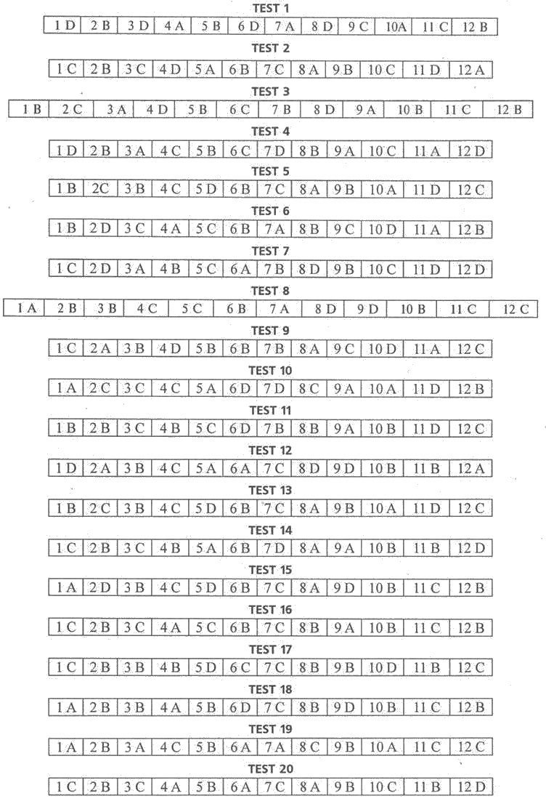

WORD FORMATION NOUNS

1.
1. addition
2. admiration
3. celebration
4. composition
5. cooperation
6. decoration
7. devotion
8. dictation
9. education
10. examination
11. invitation
12. observation
13. protection
14. subtraction
15. translation

2.
1. happiness
2. weakness
3. kindness
4. selfishness
5. childhood
6. adulthood
7. brotherhood
8. sisterhood

3.
1. improvement
2. government
3. management
4. election
5. spelling
6. information
7. discussion
8. jogging

4.
1. driver
2. translator
3. psychologist
4. economist
5. teacher
6. actor
7. footballer
8. architect
9. photographer
10. employer
11. sailor

5.
1. actor
2. musician
3. novelist
4. worker
5. accountant
6. visitor
7. pianist
8. violinist

6.
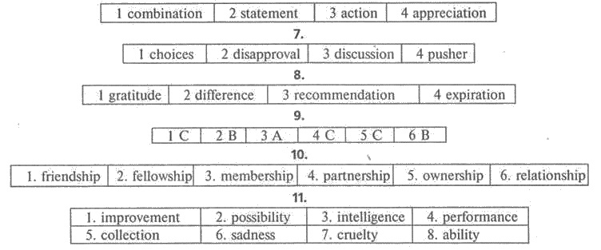

ADJECTIVES SUFFIXES

1 D | 2 A | 3 E | 4 F | 5 J | 6 K | 7 H | 8 I | 9 G | 10 В | 11 C

2.
1. interesting
2. enthusiastic
3. fluent
4. sensational
5. national
6. democratic
7. helpful
8. hungry
9. experimental

3.
 | Positive meaning -ful | Negative meaning - less
Beauty | beautiful
Brain |  | brainless
Care | careful | careless
Charm |  | charmless
Event | eventful
Faith | faithful | faithless
Harm | harmful | harmless
Help | helpful | helpless
Hope | hopeful | hopeless
Home |  | homeless
Pain | painful | painless
Peace | peaceful
Penny |  | penniless
Power | powerful | powerless
Sleep |  | sleepless
Taste | tasteful | tasteless
Thought | thoughtful | thoughtless
Time |  | timeless
Use | useful | useless

4.
1. delightful
2. fearless
3. endless
4. thankful
5. cheerful
6. skillful

5.
1. cheerful
2. unhappy
3. gently
4. unable
5. kindly
6. dangerous

6.
1. foolish
2. central
3. valuable
4. humorous
5. comfortable
6. athletic
7. starry
8. friendly

7.
eligible | inedible
personable | undigestible
fashionable | possible
remarkable | contemptible
horrable

8.
1. invisible, incredible, laughable
2. irresponsible, breakable
3. comfortable, fashionable
4. irritable, flexible
5. permissible
6. valuable, dependable
7. suitable, illegible

9.
1 В | 2 В | 3 В | 4 A | 5 C
6 C | 7 A | 8 D | 9 В

10.
1. stressful | 7. beneficial
2. successful | 8. pleasant
3. competitive | 9. confident
4. nervous | 10. energetic
5. exhausted | 11. suitable
6. inactive

ADJECTIVES PREFIXES

1.
1. unsocial
2. dishonest
3. illegible
4. immature
5. unacceptable
6. irresponsible
7. misleading
8. unhappy
9. unfed
10. undeveloped
11. underdone
12. overcrowded

2.
1 A | 2 В | 3 В | 4 A | 5 В | 6 В

3.
1. supersonic
2. infertile
3. afloat
4. alive
5. mistaken
6. impolite
7. afoot
8. anti-tank

4.
1. immoral
2. illegible
3. abnormal
4. hyperactive
5. maladjusted
6. overweight
7. supernatural
8. understaffed

5.
1 A | 2 C | 3 C | 4 A
5 C | 6 В | 7 C | 8 C

6.
1 D | 2 A | 3 C
4 В | 5 F | 6 E

7.
1. unfriendly
2. unreasonable
3. uninformed
4. invaluable
5. inappropriate
6. misinterpreted
7. disapproved
8. inattentive

8.
1. indecent
2. immobile
3. unimportant
4. inaccurate
5. untidy
6. unusual
7. invisible
8. disinterested

9.
1. comfortable
2. greenish
3. childish
4. unpronounceable
5. unpractical
6. unthoughtful
7. unsuccessful
8. anti-war
9. disastrous
10. boring
11. uncommon

10.
1 D | 2 E | 3 C | 4B | 5 A
6 C | 7 В | 8 D | 9 E | 10 A

WORD FORMATION TESTS

TEST 1
1 | invitations
2 | journalists
3 | politicians
4 | celebration

TEST 2
1 | uniquely
2 | consultant
3 | traditional
4 | treatments
5 | reasonable

TEST 3
1 | harmful
2 | conclusion
3 | reactions
4 | regularly
5 | steadily

TEST 4
1 | wonderful
2 | skiing
3 | swimming
4 | choice
5 | tourists
6 | performance
7 | historic
8 | romantic
9 | absolutely

TEST 5
1 | vacationers
2 | necessarily
3 | recognition
4 | specific
5 | recreational
6 | amusement

TEST 6
1 | eastern
2 | breathtakingly
3 | sandy
4 | compensate
5 | neighboring
6 | mountainous

TEST 7
1 | application
2 | employer
3 | importance
4 | highly
5 | clearly
6 | effectively

TEST 8
1 | sandy
2 | energetic
3 | tension
4 | daily
5 | famous
6 | historical
7 | luxurious
8 | residence

TEST 9
1 | spicy
2 | Gradually
3 | fashionable
4 | choice
5 | nobility
6 | affordable
7 | popularity

TEST 10
1 | fortunately
2 | treatments
3 | minimize
4 | healing
5 | constantly
6 | prescribe

TEST 11
1 | constantly
2 | numerous
3 | attractive
4 | development
5 | natural
6 | effectiveness

TEST 12
1 | southern
2 | glorious
3 | vary
4 | golden
5 | tourism
6 | presence
7 | architecture
8 | fertile
9 | traditional
10 | numerous

TEST 13
1 | medical
2 | pollutants
3 | require
4 | prescription
5 | interventions
6 | typically
7 | painful
8 | appearance
TEST 14
1 | researchers
2 | designer
3 | professionals
4 | information
5 | magnetic
6 | limitations
7 | non-reliability
8 | original

TEST 15
1 | Historians
2 | inventor
3 | independently
4 | invention
5 | painter
6 | musician
7 | hearing
8 | demonstrations

GAPPED TEXTS





